**Name:Raksha**

**Date: 29/7/25**

**Batch11**

**Taks: vm creation thorugh azure cli**

***************************************************************

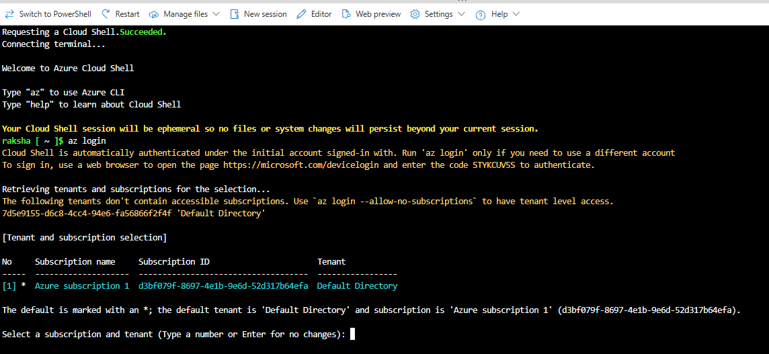

Az account list

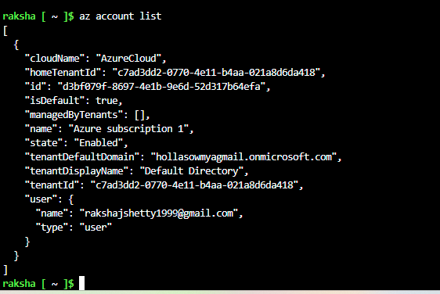

Az group list

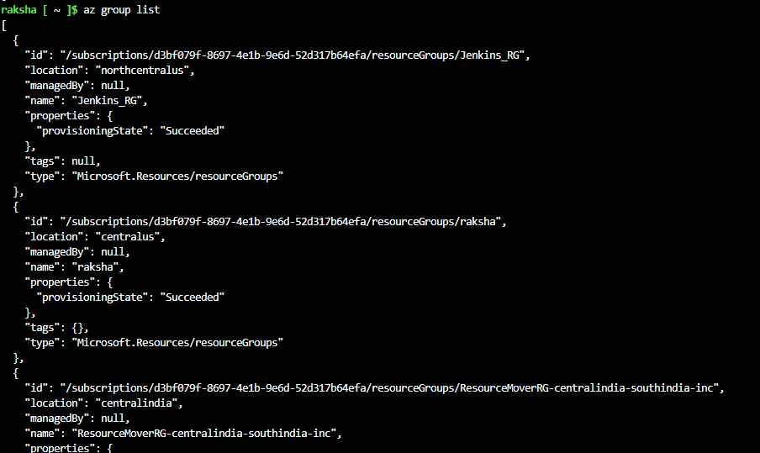

Az group list -o table

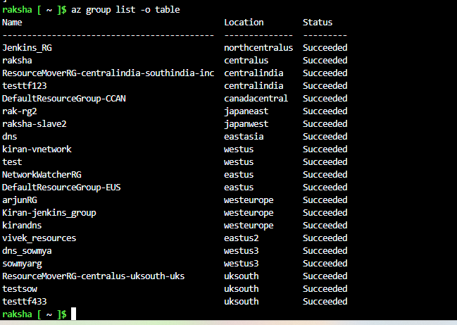

Contributor role has created using azure subscription

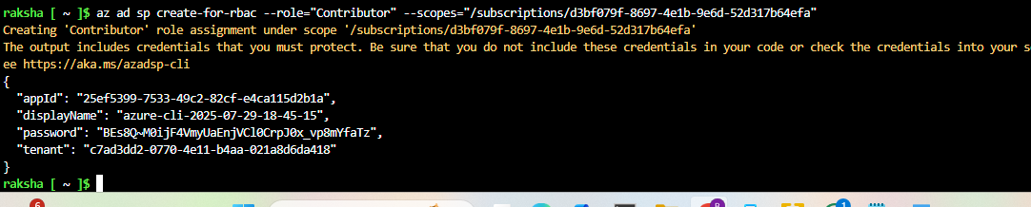

Client secret value

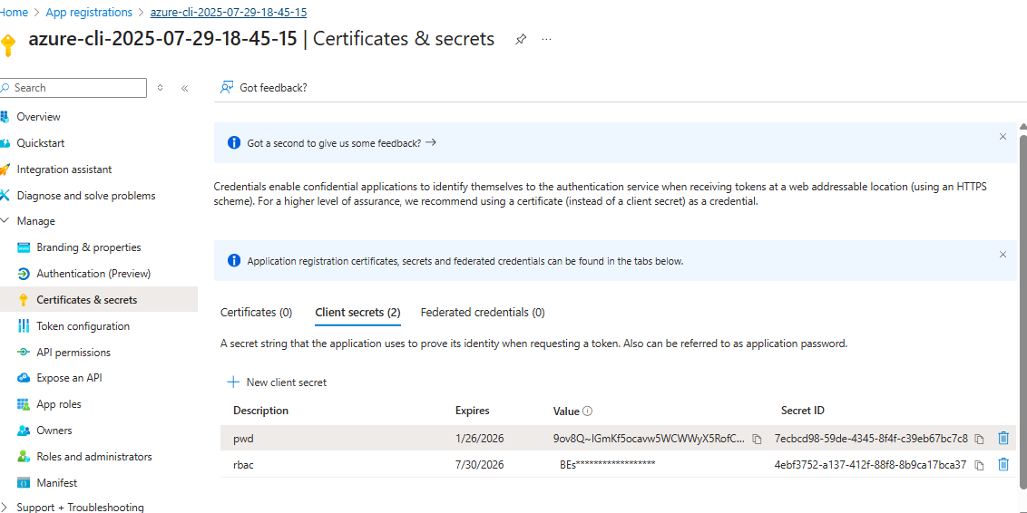

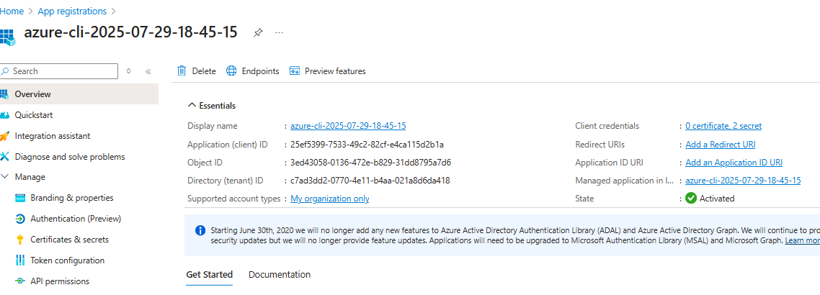

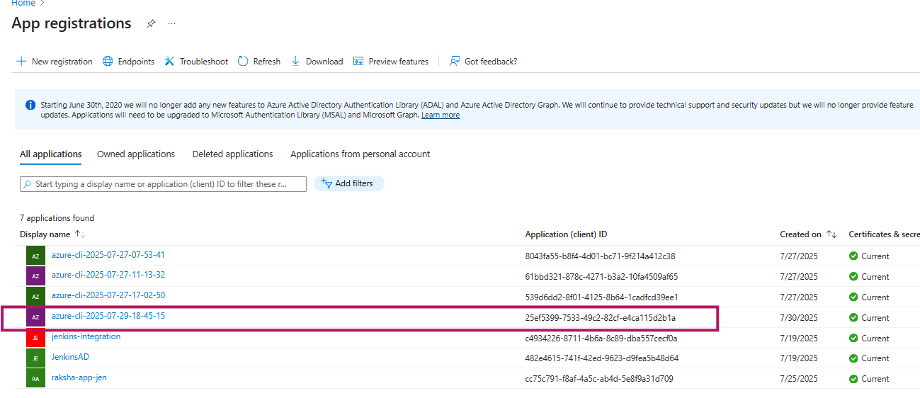

Create one folder azure-> go inside-> create res,tf file

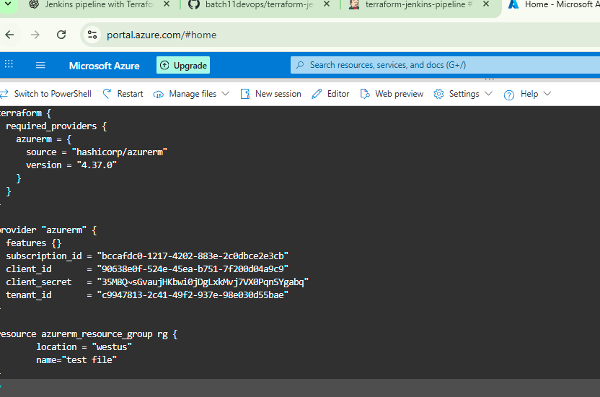

Terraform init

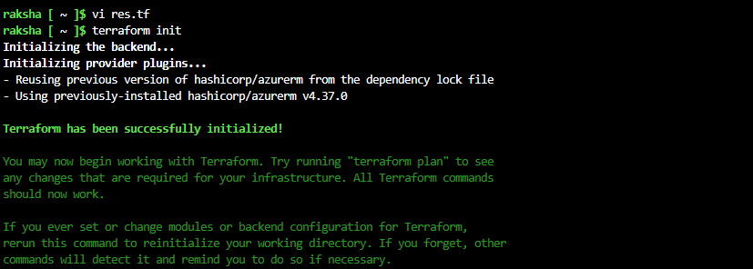

Terraform apply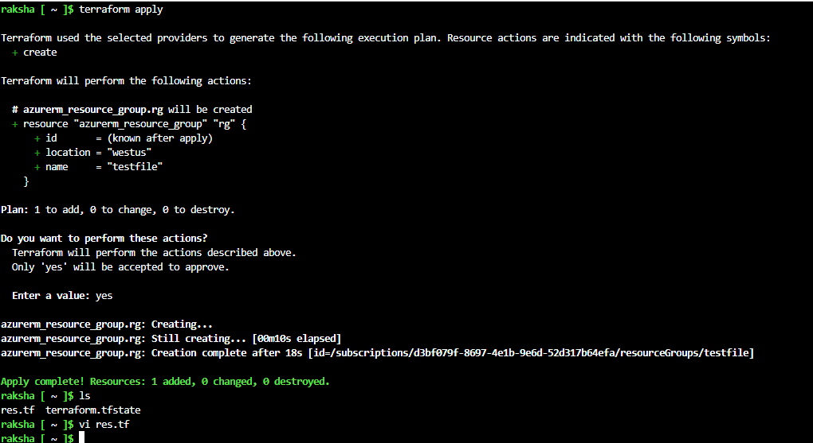

Created testfile rg

